* **Decimal expansion** of fraction, to write it
  + 1/16 = 0.0625, ½ = 0.5
  + 1/12 = 0.08333333333 .. 3 repeats for ever
  + 5/7 = 0.714285714285714285…. 714285 repeat forever
  + ⅙ = 0.1(6), 1/12 = 0.08(3). 5/7 = 0.(71428), ½ = 0.5(0)
* How to know # of digits before cycle of n/d?

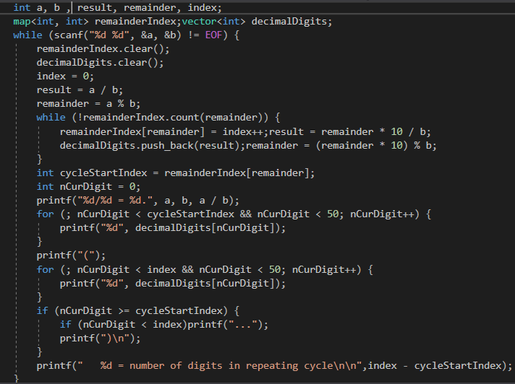

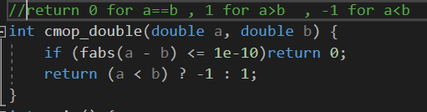

Big factorial

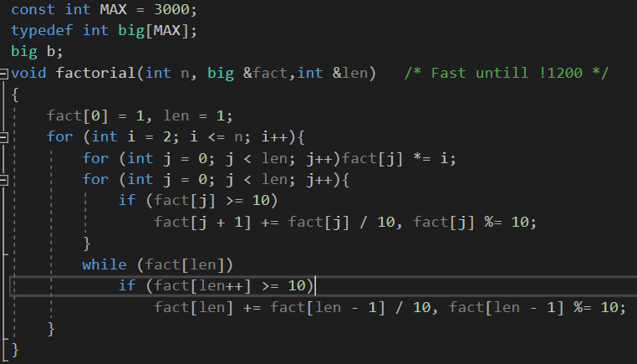

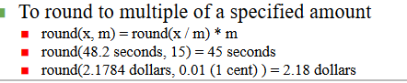

Number of primes in range(1:n) = n/log(n)

Wilsons’s theorem (p-1)!%p = p-1 if(p is prime ) ^^

Big Product

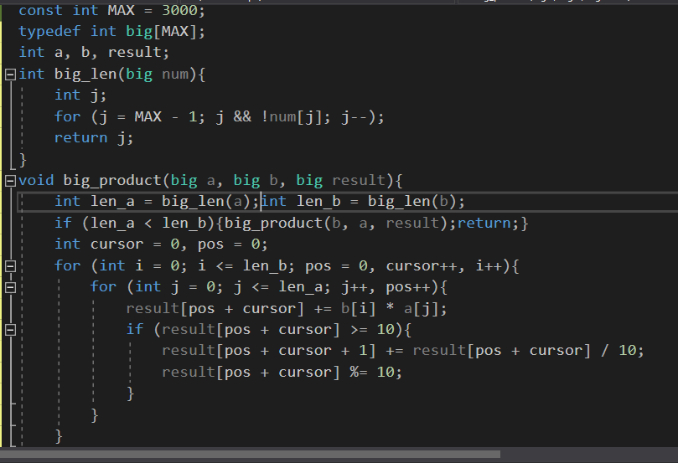

Log -> digits = 1 + floor(log10(x))

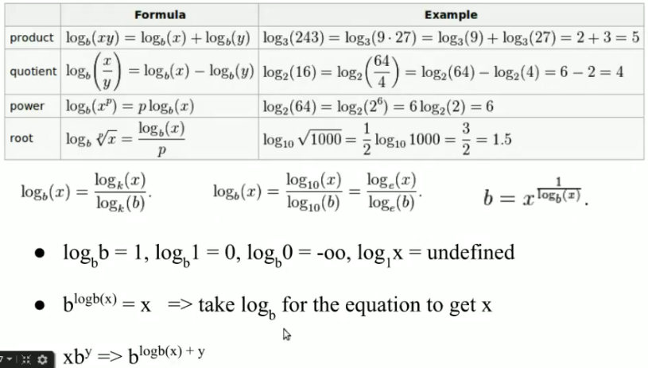

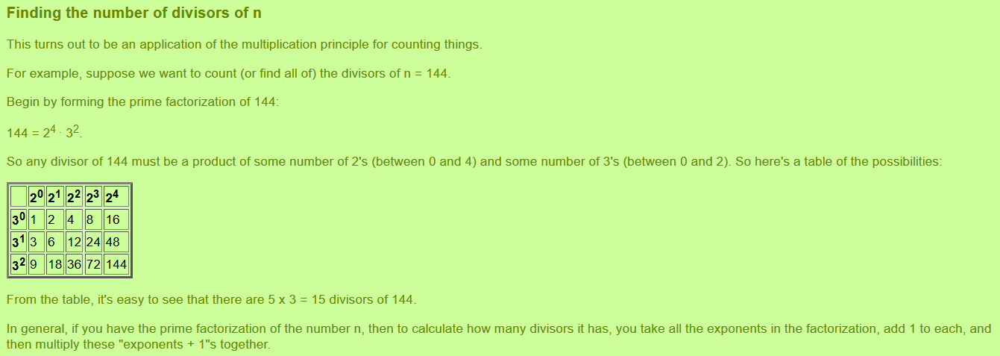

If you have number you need to know number of bits -> bit = log(num)/log(2) ;

Points in the same line ^^

